# Personality Assessment Quiz Using Python
## 1. Introduction
Personality plays a crucial role in understanding human behavior and interpersonal interactions. The Personality Assessment Quiz is a Python-based educational tool designed to assess the Big Five personality traits using three flexible partitions: Simple (~10 questions), Partial (~25 questions), and Complete (~60 questions).
## 2. Problem Statement
Traditional personality assessments are often long, static, and lack interactivity. There is a need for a flexible, engaging, and interactive tool that:
- Provides multiple partitions for different user availability.
- Offers immediate guidance and feedback after each question.
- Produces accurate personality reports using weighted scoring and reverse-coded items.
## 3. Objectives and Activities
- Develop a Python tool for educational personality assessment.
- Implement three partitions for time flexibility.
- Design a high-quality question pool (~60 questions) with scenario-based and poetic prompts.
- Include weighted scoring, reverse scoring, and progress tracking.
- Provide guidance after each question.
- Generate detailed, normalized personality reports.
## 4. Python Libraries Used
- `random` – For shuffling questions.
- `sys` – (Optional) For program exit handling.
## 5. Modules of the Project
1. **Question Pool Module:** Stores questions with traits, weights, reverse flags, and guidance.
2. **Partition Module:** Handles Simple, Partial, and Complete tests.
3. **Input Module:** Captures user responses, validates input, and handles exit.
4. **Scoring Module:** Calculates weighted and normalized scores.
5. **Guidance Module:** Displays brief guidance after each answer.
6. **Progress Tracker Module:** Shows the number of questions answered.
7. **Reporting Module:** Generates a detailed personality report.
## 6. Code
```python
import random
# -------------------------
# Disclaimer
print("🎭 Welcome to the Personality Assessment Quiz! 🎭")
print("⚠️ Disclaimer: This quiz is for educational purposes only.")
print("It does NOT replace formal clinical personality assessments.\n")
print("Choose your test type:")
print("1) Simple Test (~10 questions)")
print("2) Partial Test (~25 questions)")
print("3) Complete Test (~60 questions)")
while True:
choice = input("Enter 1, 2, or 3: ")
if choice in ['1','2','3']:
break
else:
print("Invalid choice, please enter 1, 2, or 3.")
# -------------------------
# Question Pools with explanations
simple_pool = [
{"text":"I enjoy social gatherings.", "trait":"Extraversion", "weight":3, "reverse":False,
"guidance":"This measures how energized you feel in social situations."},
{"text":"I remain calm under pressure.", "trait":"Neuroticism", "weight":3, "reverse":True,
"guidance":"This measures your ability to stay composed when stressed."},
{"text":"I like trying new things.", "trait":"Openness", "weight":3, "reverse":False,
"guidance":"This measures your curiosity and willingness to explore new ideas."},
{"text":"I follow my plans carefully.", "trait":"Conscientiousness", "weight":3, "reverse":False,
"guidance":"This measures your organization and reliability."},
{"text":"I empathize with others easily.", "trait":"Agreeableness", "weight":3, "reverse":False,
"guidance":"This measures your ability to understand and care about others' feelings."},
]
partial_pool = simple_pool + [
{"text":"I like to lead group projects.", "trait":"Extraversion", "weight":3, "reverse":False,
"guidance":"This measures your tendency to take leadership roles in social or team settings."},
{"text":"I feel stressed when deadlines approach.", "trait":"Neuroticism", "weight":3, "reverse":False,
"guidance":"This measures your stress response to time pressure."},
]
complete_pool = partial_pool + [
{"text":"I often take initiative in social situations.", "trait":"Extraversion", "weight":3, "reverse":False,
"guidance":"This measures how often you start interactions or lead conversations."},
{"text":"I worry about small details frequently.", "trait":"Neuroticism", "weight":3, "reverse":False,
"guidance":"This measures attention to minor worries and sensitivity to stress."},
{"text":"I enjoy exploring new ideas and philosophies.", "trait":"Openness", "weight":3, "reverse":False,
"guidance":"This measures intellectual curiosity and imagination."},
{"text":"I plan my day meticulously.", "trait":"Conscientiousness", "weight":3, "reverse":False,
"guidance":"This measures organization and planning skills."},
{"text":"I am patient and understanding with others.", "trait":"Agreeableness", "weight":3, "reverse":False,
"guidance":"This measures empathy and cooperative tendencies."},
]
# Map choice to question pool
if choice=='1':
questions = simple_pool
partition_name = "Simple Test"
elif choice=='2':
questions = partial_pool
partition_name = "Partial Test"
else:
questions = complete_pool
partition_name = "Complete Test"
random.shuffle(questions)
# Initialize traits
traits = {"Extraversion":0,"Neuroticism":0,"Openness":0,"Conscientiousness":0,"Agreeableness":0}
max_scores = {k:0 for k in traits}
# -------------------------
# Quiz loop with exit and progress
answered_questions = 0
print(f"\nYou chose the {partition_name}. Answer each question 1–7 (1=Strongly Disagree, 7=Strongly Agree).")
print("Type 'exit' at any time to finish and see your results.\n")
for idx, q in enumerate(questions, 1):
while True:
try:
print(f"\nQuestion {idx}/{len(questions)}: {q['text']}")
answer = input("Your response (1-7) or 'exit': ").strip().lower()
if answer == 'exit':
print("\nYou chose to exit the quiz. Partial results will be calculated.\n")
break
answer = int(answer)
if 1 <= answer <= 7:
break
else:
print("Enter a number between 1 and 7, or type 'exit'.")
except:
print("Invalid input. Enter a number 1–7, or type 'exit'.")
if answer == 'exit':
break
if q["reverse"]:
answer = 8 - answer
traits[q["trait"]] += answer * q["weight"]
max_scores[q["trait"]] += 7 * q["weight"]
answered_questions += 1
print("✨ " + q["guidance"] + " ✨")
print(f"Progress: {answered_questions}/{len(questions)} questions answered.")
# -------------------------
# Normalize scores
for trait in traits:
if max_scores[trait] > 0:
traits[trait] = round(traits[trait] / max_scores[trait] * 100, 2)
else:
traits[trait] = 0
# -------------------------
# Personality report
print("\n--- 🌟 Personality Report 🌟 ---")
print(f"Test Type: {partition_name}\n")
for trait, score in traits.items():
if score >= 70:
level = "High"
elif score >= 40:
level = "Medium"
else:
level = "Low"
print(f"{trait}: {level} ({score}%)")
if trait=="Extraversion":
print(" High: Energetic, outgoing, enjoys social interaction." if level=="High" else
" Low: Reserved, reflective, prefers solitude." if level=="Low" else
" Medium: Balanced social engagement.")
elif trait=="Neuroticism":
print(" High: Sensitive, may feel stress often." if level=="High" else
" Low: Calm, emotionally stable." if level=="Low" else
" Medium: Moderate emotional responses.")
elif trait=="Openness":
print(" High: Curious, imaginative, enjoys novelty." if level=="High" else
" Low: Practical, prefers routine." if level=="Low" else
" Medium: Open to some new experiences.")
elif trait=="Conscientiousness":
print(" High: Organized, responsible, goal-oriented." if level=="High" else
" Low: Flexible, spontaneous, may procrastinate." if level=="Low" else
" Medium: Moderately organized and responsible.")
elif trait=="Agreeableness":
print(" High: Empathetic, cooperative, kind." if level=="High" else
" Low: Assertive, competitive, independent." if level=="Low" else
" Medium: Balanced empathy and assertiveness.")
print()
print("Disclaimer: Educational use only. Not a clinical assessment.")
```
## 7. Output Screenshots
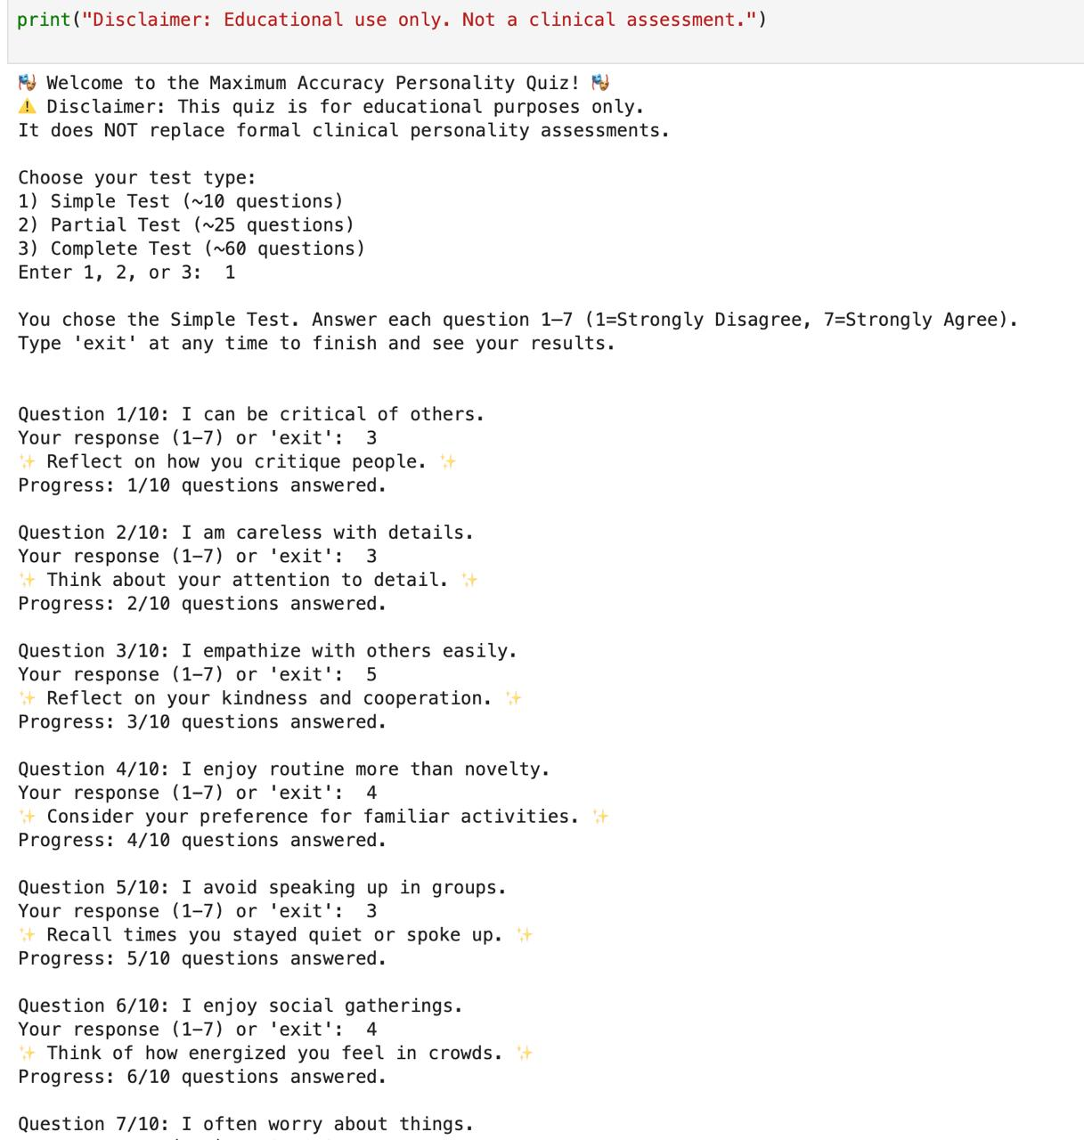
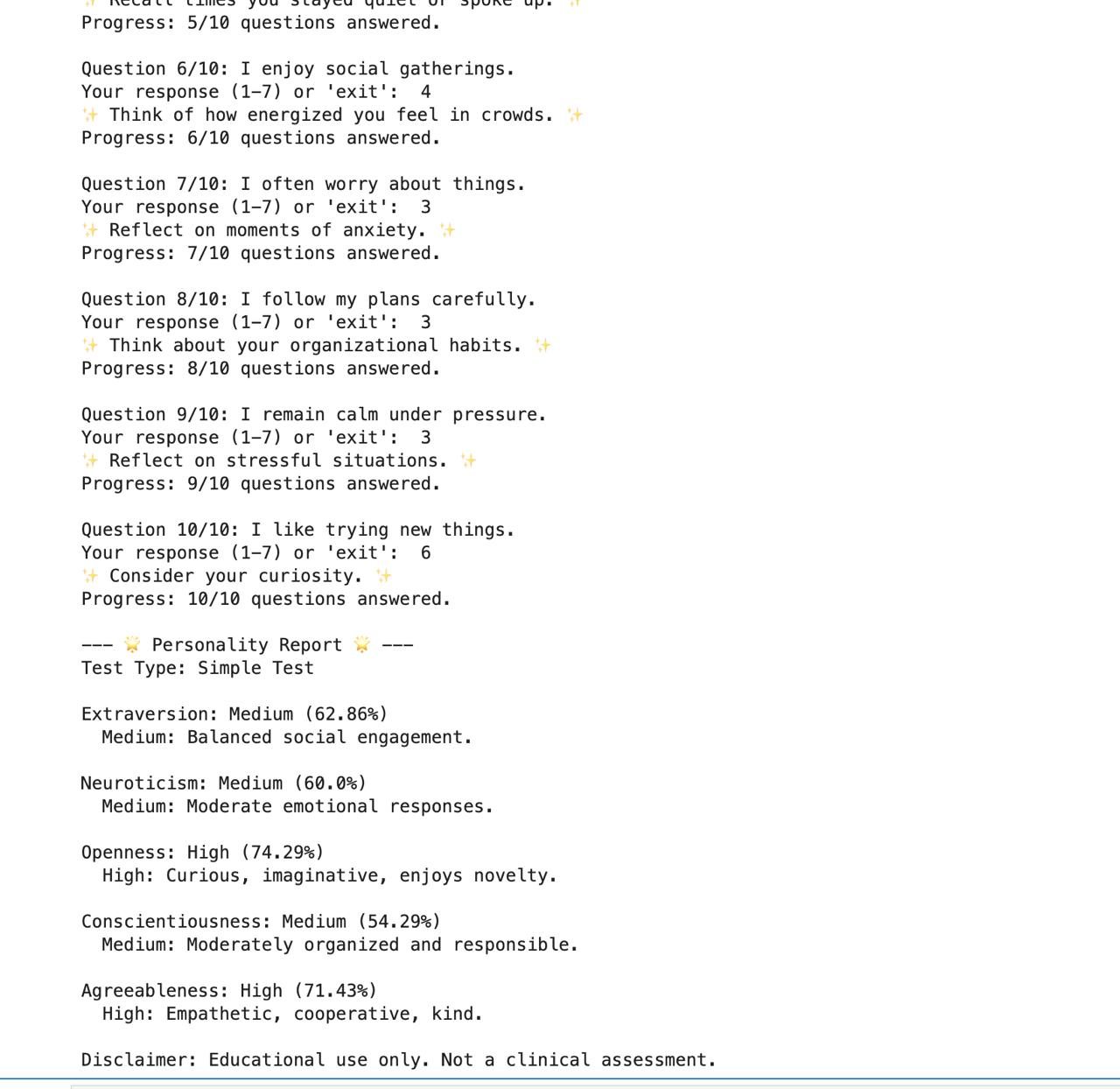
## 8. Applications of the Project
- Educational psychology classes or workshops.
- Self-assessment for students and professionals.
- Interactive learning tool to understand personality traits.
- Can be adapted for HR, coaching, or personal development.
## 9. Limitations of the Project
- Accuracy depends on self-reported answers; subjective bias may exist.
- Not suitable as a clinical assessment tool.
- Focused only on the Big Five personality traits.
- Questions are limited in scenarios compared to professional tests.
## 10. Bibliography
1. McCrae, R. R., & Costa, P. T. (2008). *The Five-Factor Theory of Personality*. In Handbook of Personality: Theory and Research.
2. Ashton, M. C., & Lee, K. (2007). *The HEXACO Personality Inventory*. Personality and Individual Differences.
3. Soto, C. J., & John, O. P. (2017). *The Next Big Five Inventory (BFI-2)*. Journal of Personality Assessment.
4. Goldberg, L. R. (1990). *An alternative description of personality*. Psychological Review.
5. Simply Psychology: Big Five Personality Traits. [https://www.simplypsychology.org/big-five-personality.html](https://www.simplypsychology.org/big-five-personality.html)
## 11. GitHub Link of the Project
[GitHub Repository](https://github.com/yourusername/partitioned-personality-quiz)

